

**Project Title: -** Zero Trust Network -

**Abstract:**

ZTA is a new approach to cybersecurity that benefits firms who have sensitive data & outsource staff who do not operate from office computers. It safeguards various resources such as information, internet backbone identities, and other services. The word derives from the system's essential idea of verifying each access to the source. The verification operation is performed regularly based on traffic workload regardless of computer or human position. Using the same machine while "conserving" the potential of information availability is impossible. In this research, we use Cloudflare to deploy an application and implement a zero trust model.

**Keywords:** *Zero trust; cloudflare; Azure; Aws; Security; Roles based*

**Acknowledgements**

It would be hard to complete my project without the guidance of several people who helped me to make my dissertation successful. First of all, I wish to thank my supervisor *******, who gave me permission to make the project on “honey pot”. With his sincerity and encouragement, it is possible to complete my project on time. He gave me all possible information and suggestion to make and improve my project. Moreover, I would like to thank “The University of Bedfordshire”, which gave me an opportunity to study here to improve my future. The Administration of the university is very helpful which encourage students to make their profession. It provides several services, which are useful for my study and project. It is a pleasure to say thanks to my family and friends who support me all the time in my study.

**Dedication**

**Dedicate this to my family**

Contents

Lists of figures 4

Abbreviation: 5

CHAPTER 1: Introduction 6

1.1 Background 6

1.1 Aims 12

1.2 Objectives 12

1.3 Artefact Description 12

1.4 Thesis Structure 12

CHAPTER 2: Literature Review 14

Summary: 22

CHAPTER 3: Research Methodology 22

3.1 Case study of different cases: 24

Case 1: Employee Internet Resource Availability 24

Case study 2: Inter-server Communication Within the Organization 25

Case study 3: Create a trust score/level of confidence using corporate resources. 25

Case Study 4: Access to Enterprise Resources for Employees 25

3.2 High level Methodology: 26

List of Features 26

3.3 Cloud based implementation of Zero trust model 27

All of your applications will have ZT cloudflare access. 27

Enforce your organization's AUP: 27

All browser code should be performed on the cloud 27

What is identity on Cloudflare ZT? 28

Role and permission on cloudflare: 28

Summary: 28

CHAPTER 4: Implementation 29

4.1 Implementation of Cloud flare ZTA 29

Installation & configuration of Dashboard 29

Add application: 32

Policy creations 33

CHAPTER 5: Testing / Results 36

5.1 Check Cloud flare ZT devices: 36

5.2 Check user in ZT: 36

5.3 Data Analytics 37

5.4 Analysis Logs 37

Summary: 38

CHAPTER 6: Conclusions 39

References 40

Appendices 42

Appendix 1: Cloud flare 42

Appendix 2: cloudflare contents.ts 46

# Lists of figures

Figure 1 ZTA in logical function 8

Figure 2 WAF architecture 16

Figure 3 survey on previous research 17

Figure 4 Principle of ZTA 18

Figure 5 Authors used block structure 18

Figure 6 proposed method 19

Figure 7 ZTA implementation in Covid 19 20

Figure 8 Authors proposed ZTA 21

Figure 9 with zero trust model various access the services 22

Figure 10 Analyze flow diagram in ZTA. 23

Figure 11 Mechanism in action in ZTA 24

Figure 12 High level ZTA methodology 26

Figure 13 boarding page 29

Figure 14 Dashboard screen after creating account 30

Figure 15 welcome to ZT screen 30

Figure 16 input team name 31

Figure 17 welcome dashboard 31

Figure 18 add the location of DNs and give ip address 32

Figure 19 Dashboard for adding application 32

Figure 20 Application name 33

Figure 21 Application logo 33

Figure 22 Policy 1 34

Figure 23 Policy 2 35

Figure 24 View Devices in Cloudflare ZT 36

Figure 25 View users 37

Figure 26 Data Analytics Dashboard 37

Figure 27 Log analysis 38

# Abbreviation:

CC: cloud computing

ZTA: Zero trust Architecture

IoT: Internet of things

BYOD: Bring Your Own Device

WFH: Work from home

# CHAPTER 1: Introduction

## 1.1 Background

A typical company's network has become increasingly complex. A branch may be accountable for many private systems, regional offices with their shared infrastructure, external & smart phones, & cloud services (Gilman, 2017). This complexity has overtaken traditional perimeter-based network security corporate techniques since no easily defined network constraint exists. The effectiveness of perimeter-based network security has also been revealed. When an attacker breaches the barrier, lateral movement is unhindered.

Through the development of better software and systems, technological growth creates new & more accessible ways of life. CC and the (I0T) dramatically improve today's IT infrastructure (Samaniego, 2018). These developments, however, bring with them significant problems. As IT systems evolve, hackers' and bad actors' abilities are swiftly adopted and perfected to an incredible degree. A current comprehensive assault on Solar Wind Orion, an IT management & monitoring software affecting global victims, is presented as an example. This global infiltration was conducted via a distribution network attack using a malware backdoor. The campaign is thought to be using many obfuscating and evasive strategies (Mehraj, 2020).

Everything within the external company's network is regarded as trustworthy." Until recently, this was the notion in which we believed and constructed our infrastructure. Classical border protection splits networks into two categories: interior & outside network. However, internal area connects every devices such as mobile phones, laptops etc inside a set boundary depending on the physical location of the devices, whereas the taken out of context covers everything else (Garbis, 2021). Firewalls, IDS, intrusion prevention systems (IPS), as well as other security controls are typically implemented at the company network's edges (borders) to create a secure boundary (or "network perimeter") which differentiates its intranet from the rest from Internet. This is the fundamental idea behind edge information security (Campbell, 2020).

In general, the classic approach of perimeter-edge security permits the usage of absolute trust, in which the topic is regarded trustworthy once validated and permitted to join the internal network. Once within the internal network, a malicious (vulnerable) user can execute the additional movement and wander freely.

It is an IT security approach that necessitates stringent character checks for every person and device seeking access to assets in a private company, whether they are located inside or outside the organization's perimeter (Stafford, 2020). The fundamental invention associated with Zero Trust engineering is ZTNA; nevertheless, ZT is an all-encompassing approach to network security that incorporates a few specific standards and breakthroughs. Basically, customary IT network security confides in anybody and anything inside the organization. A Zero Trust engineering confides in nobody and nothing.

Customary IT network security depends on the palace and channel idea. It is difficult to get access from outside the organization in palace and channel security. However, everybody inside the organization is trusted, of course. The issue with this approach is that once an assailant accesses the organization, they have free rein over everything inside (Greenwood, 2021).

As innovations keep on propelling, clients' requests and ways of life are additionally evolving quickly. Cloud advances offer us better approaches to getting to administrations and assets anytime and with significant expense execution. These days, individuals are not generally expected to work from their office/work environment; all things considered, they can work from a distance from any place as long as all assets expected to play out their occupation are accessible. With the advent of the BYOD strategy and the ongoing COVID-19 pandemic, remote indefinitely, WFH has become something normal (so-called "new normal") for some organizations (Yao, 2020). For example, in November 2020, Square Enix, a large Japanese device game company, offered its people the opportunity to work remotely indefinitely, demonstrating a profound transformation in perspective.

Presently, the inquiry lies in what this adjustment of worldview means for an association concerning security. The inheritance border-based network security is thought of as lacking since the clients are permitted to work from a distance from any spot which may not be situated inside the got edge. Subsequently, it has become extremely challenging to characterize or draw the specific boundaries/edges, not to mention getting them.

These concerns resulted in the ZT concept, which states that a venture should understand that there can be no assumed loyalty in each topic. The ZT architecture regards venture-owned conditions as no more reliable than any no enterprise-claimed environment.

It is a venture network safety design that depends on nothing trust standards and is intended to forestall information breaks and cutoff inside horizontal development. This distribution talks about ZTA, its legitimate parts, conceivable sending situations, and dangers. It likewise presents a comprehensive guide for associations wishing to move to a zero-trust plan approach and examines effective government strategies that might affect or impact a zero-trust design (Ramezanpour, 2021).

ZT is certainly not solitary engineering; however, many core values for the work process, framework plan, and activities can be utilized to further develop the security stance of any grouping or responsiveness level. Changing to ZTA is an excursion concerning how an association assesses risk in its central goal and can't just be achieved with a discount substitution of innovation. All things considered, numerous associations have components of a ZTA in their undertaking framework today. Associations gradually execute zero trust standards, process changes, and innovation arrangements that safeguard their information resources and business capacities by use case. Most venture foundations will work in a half breed zero trust/border based mode while proceeding to put resources into IT modernization drives and further develop association business processes (do Amaral, 2021).

Companies need to carry out complete data security and flexibility rehearses for zero trust to succeed. When offset with existing network safety strategies and direction, personality and access to the executives, consistent checking, and best practices, a ZTA can safeguard against normal dangers and further develop an association's security pose by utilizing an oversaw risk approach.

Components, conventional ZTA simulations, and now a short introduction to the trust computation are introduced and analysed individually in the subsection.

As indicated in Figure 1, ZTA has five major, constant parts: topic, asset, technique choice point  (PEP), & augment. The issue refers to a customer or any device mentioning access to the business resources. As the title suggests, asset refers to a corporate/venture asset described by a topic. Depending on the nature of the solicitation, the asset might be a unique asset or a collection of assets.

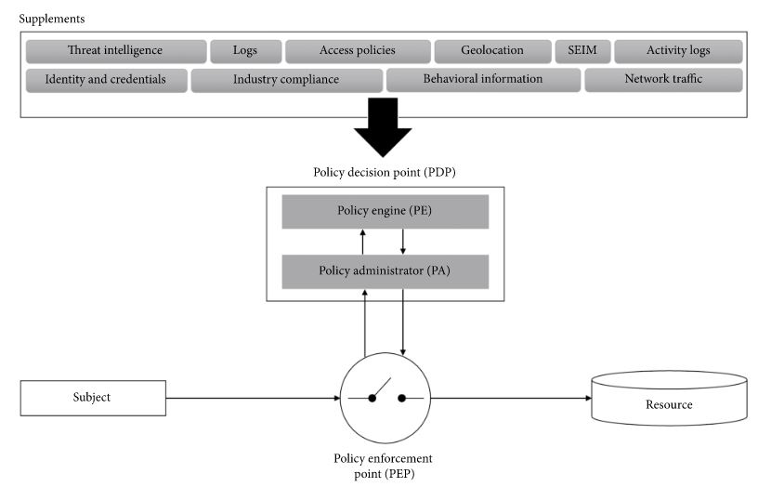

Figure ZTA in logical function

A PDPw2 is liable for permitting or denying admittance to the undertaking asset and layout or ending the correspondence between a subject and an asset being mentioned. PDP can be separated into strategy motor and strategy chairman, which are answerable for independent direction and correspondence with the board individually.

A subject sends a solicitation to get to an undertaking asset which winds up shipping off the strategy requirement point (PEP). The PEP advances the solicitation to PDP. After the PDP chooses how to manage the solicitation, it orders the PEP to empower or end the correspondence between the subject and the asset. As we will see, PEP is an entryway between the subject and assets. Controlling the progression of the correspondence and answerable for observing the organization traffic going between the subject and the mentioned asset (Albuali, 2020).

Finally, the accessory gives the PE useful data (e.g., danger knowledge data and organization/framework logs). This permits PE to pursue more exact and address choices (less misleading positive and bogus negative), which likewise improves the framework's general security.

There are both specialist and specialist-less methodologies with PEP as an entryway to the undertaking assets. The PEP can be joined to solitary or various assets or an entryway to all endeavor assets. NIST SP 800-207 orders ZTA sending into 4 sorts, i.e., gadget specialist based, territory-based, asset entryway based organizations, and in conclusion, the ZTA arrangement utilizing gadget application sandboxing, contingent upon how assets are overseen and shielded.

The key benefit of this ZTA is the potential to provide accessibility to the worker regardless of location. The notion of "do not ever believe, always check" is central to ZTA. The system is focused on signalized intersections, efficiency, and level of consumption. Another key advantage that should not be overlooked is the automation of operations.  The program's computation and processing capability are far superior to human capabilities.

The issue of validating a cellphone or perhaps a computer also is an important one in the cybersecurity field.  ZTA  suggests a new approach that regulates just traffic & does not grant access to data based on the phone's geolocation & user ID. Some firms, for example, opt to use two-factor identification to reduce potential data threats. The motivation for developing ZTA is that there is no location where personal information can be kept safe.

Especially 50 years earlier, the company's headquarters was perhaps the safest safe room since the only staff had access to operational computers. Technological advancements make it feasible to hack into a system without physically being there. As a result, companies dealing with private and secret data or copyrighted material will benefit from the ZTA initiative. This study aims to look into the program's specifics, the function of its novel methodology, & the effect on the trustworthiness of firms' databases (Wu, 2021).

**Attacks surface:**

ZTA's focal points are the approaches to decision points & PEP. It is in charge of deciding whether to give or refuse access to the initial asset and handling the relationship between the subject and the investment portfolio. Zero trust architecture, those central sections might serve as additional targets for enemies. Unlike the typical edge-based structure, ZTA may suffer the consequences of attacks on these central components, such as DDoS, route hijacking, or storage network assaults on PDP. Disrupting PDP & PEP duties may halt the venture institution's tasks. Similarly, if PE is breached, it may cause harm to the organization ( data alteration or leaking).

Furthermore, all resources may be targeted because there may no longer be a partition to protect experience capital. Malfunctioning resources or records with a high level of access honor, particularly those with access permission to assets of interest to an aggressor (corporate and financial data), are most likely critical targets of attacks.

* **Denial of services**

The PDP, which consists of (PE) & (PA), might be another attack target because PDP does not completely decide whether to accept or reject the admission. Impairing or disrupting PDP will also significantly impact such a decision cycle, which might result in the termination of duties. One technique for reducing such organizational disruption attacks is to place PDP ( PE and PA) on the cloud climate, which is stronger even in low-light conditions (Gasti, 2013).

* Not approved Changes

According to NIST, the framework administrator may make unapproved modifications or accidentally make misconfigurations that may disrupt or create flaws in the framework. A faulty or corrupted PE might grant access to a few restricted assets that would otherwise be prohibited. Similarly, a compromised PA may allow adversaries to bypass the PE's decision cycle and directly access the project asset.

The logging & observation of PDP activities is recommended in NIST to reduce suck possibilities. Also, with all reported adjustments, PE and PA should be properly developed. Finally, both PE & PA should be subjected to scrutiny.

* Certification

In ZTA, all resources are not certainly trusted and have the chance of being gone after, given their significance and the significance of the data they hold. A few resources or records are bound to be designated. Compromising a record or resource isn't something new and exceptional to the zero trust engineering. With the new BYOD strategy, it might be simpler for an assailant to think twice about its resources effectively. Since BYOD gadgets are not constrained by the undertaking, they may not get the most recent security fix or might not have any antimalware instrument introduced. Since there is no such mass of security as border-based engineering, an advanced ZTA ought to forestall or obstruct compromised resources or records from getting to big business assets.

A subject getting to any asset outside its not unexpected access example might raise a banner that can prompt a more exhaustive examination. One method for moderating such an issue is to screen the subject's way of behaving, which could incorporate login history and example, term, and asset access design. A genuine instance of conveying a conduct-based approach in ZTA. The subject's way of behaving is constantly noticed and determined into a conduct trust (BT). Admittance to an asset is conceded provided that BT surpasses the trust limit (TT), which might change powerfully relying upon the climate.

* Network Traffic Monitoring & Inspection

ZTA depends on start to finish correspondence which ordinarily contains encoded data. Some outsider programming/administrations are completely scrambled, making performing a full bundle examination truly challenging or difficult. This leaves the undertaking no decision except to perform bundle examination in light of the metadata of the parcel. Be that as it may, it is recommended in [2] to consolidate AI procedures to assist with dissecting the scrambled traffic for improved effectiveness.

***Proposed Methodology***

The approach used in this research is illustrated in steps below.:

The methodological stages are written so that it always allows researchers to explore the article and then utilize the existing literature results to understand how it works. Each stage in the process is supposed to yield a result contributing to the future phases and vital information added to the report. The technique was used to analyze the ZTA & experiment with cloud flare to obtain security data. As a result, the technique is warranted.

***Research Methodology***

Because the study is investigating ZTA, NIST will be utilized as a starting point for research. The Cloud flare dashboard will be used to learn about and comprehend how it protects the connection.

The methodical technique adopted was to acquire available papers, choose the article nearest to the topic, & evaluate ZTA.

## 1.1 Aims

This research aim is to comprehend how the zero-trust network architecture method secures the user from any place & device & provides security architecture.

CC, mobile device use, and the Internet of Things have all disrupted the old network limits. The organization is developing a mechanism to secure access privileges from any place & device. The open-source project will be used to investigate how the ZTA approach protects the company.

## 1.2 Objectives

* Learn about ZTA design and how it secures the network.
* Examine many sorts of properties that are used to construct the network and user security
* Examine the components of a zero-trust network architecture that work together to provide a centralized policy point.
* Document the risks that a zero-trust network design strategy minimizes and mitigates.
* Record & analyze why traditional security cannot satisfy today's needs..

## 1.3 Artefact Description

This research will leverage the artifact created for the experiment to create a ZTA. It has the following features:

1. Execution of security mechanisms in a ZTA.

2. Implementation of the maturity model for ZTA

3. Define the logical element of the ZTA to designate a zero-trust network.

4. Collect information from the policy engine, policy administrator, and policy enforcement point to examine how each component contributes to creating a secure network architecture..

## 1.4 Thesis Structure

This research is structured as follows:

Introduction to Chapter 1

Chapter 2: Review of Literature: reviews the authors' early investigations and exposes problems in their methodologies.

Methodology (Chapter 3): The paper presents the research approaches for zero trust architecture.

Chapter 4: Implementation of ZTA in cloud flare dashboard

Chapter 5: Testing and Result of ZTA

Chapter 6: Final Thoughts/ conclusions and Future Plans

# CHAPTER 2: Literature Review

In this, I highlight the previous research of ZTA and analysis their gap. In order to determine the research gap exactly, recent literatures published in the year 2018-2022 were studied to bring out the complete insights in this research domain.

People were concerned about privacy and data integrity when the Internet was invented. The developers of social networks popularised the verification system, which is now one of the most common methods of storing personal data. The initial technique entails generating a password or a login that only the user knows. Unfortunately, the recent decade's experience demonstrates the vulnerability of this technique. The frequency of computer hackers has risen considerably in recent years. Automated tools assist crooks in this field in finding quick and simple ways to log in.

The software engineers implemented two-factor verification, which boosted security & cut the level of computer security on the firm's machines. Individually, the challenge is overcome by implementing more sophisticated usernames, including digits, letters from other languages, & particular indications. Regardless, the problem necessitates a more complex solution on a business level since the cost of error is considerably larger.

The use of the ZTA system necessitates the inclusion of two-factor verification in this software. That strategy is advantageous even though two phases must be completed in exchange for access to the database. Furthermore, it is critical to note that many firms have elected to create their credential systems. The combination of digits in these pin codes is generated at random. Furthermore, it frequently changes: once every minute or once every day, regarding the selection of the leaders. This method was an innovation in the realm of data security and is currently utilized all over the world.

It is critical to prioritize copyright protection. It would be the most important portion of the financial property since it includes information concerning possible breakthroughs & new advancements. Because the bulk of the international market is centered on technological improvement, IP rights security is a big concern in society. These truths are sometimes difficult for the average individual to comprehend, and it is therefore not the perpetrators' primary goal. The application of cloud solutions with controlled access solves these problems.  This signifies that the information somehow does not exist on a device or in a certain folder. Employees can also view the information from any place by utilizing a specialized authentication mechanism.

The zero-trust network concept is a new alternative to standard perimeter network security that has gained traction in recent years. It was first employed in the technology industry, specifically with Google's BeyondCorp, but it is now being adopted more frequently by traditional organizations. Companies are abandoning perimeter security due to its major flaw: once the perimeter is compromised, an attacker gains simple access to the restricted intranet.

The ZT model solves that vulnerability by considering all computers as if they were exposed to the network & treating the existing network as corrupted.

In this (Flanigan, 2018), study will analyze potential applications of the zero trust model and evaluate its merits and weaknesses compared to existing network models.

In this (Kerman, 2020), NCCoE project proposes an approach to zero trust system application. The creation of this planning phase initiates a procedure that would further describe the research objective and scope, as well as the computer & services pieces that will be used in a lab setting. In the laboratory, the NCCoE will build a flexible, end-to-end instance ZTA to address vulnerabilities associated with Nist Cybersecurity. This program will conclude with the release by NIST.

In this (Buck, 2021), Authors aim to solidify the present status of the information around zero trust and to recognize holes in the writing. We foster an examination system for zero-trust to structure the recognized writing and feature future exploration roads. In this manner, we lead a multivocal writing survey, dissecting both scholar and practice-situated distributions. Our outcomes show that the scholastic writing has zeroed in essentially on the engineering and execution upgrades of zero-trust. Interestingly, the focused training writing enjoys zeroed in on the authoritative benefits of zero-trust and on potential relocation procedures. Nonetheless, both the scholarly world and practice have dismissed financial investigations and client-related examinations. Future exploration might depend on our discoveries to propel the field significantly.

In this (Yan, 2020), authors research out a normal overview of the synthesis and key advancements of zero trust and join the use of this innovation in certain situations to present the benefits of zero trust, for example, enormous information work, cloud organization, and IoT. Additionally, this paper likewise talks about a portion of the field's difficult examination issues that can give future scientists thoughts.

In this (Simpson, 2020), authors' study looks at a composition that allows for regular contact while meeting network defense examination & monitoring criteria. This work is a component of the ELS framework, which is a bigger security system.

In this (Dimitrakos, 2020), authors portrays the design and model execution of a clever trust-mindful nonstop approval innovation that objectives shopper Internet of Things (IoT), e.g., Smart Home. Our methodology expands past approval models in three corresponding ways:

(1) By consolidating trust-level assessment formulae as conditions inside approval rules and strategies while supporting the assessment of such arrangements through the combination of an Attribute-Based Access Control (ABAC) approval strategy motor with a Trust-Level-Evaluation-Engine (TLEE).

(2) By presenting contextualized, nonstop observing and re-assessment of strategies throughout the approval life-cycle. That is variable credits about subjects, assets, climate, and trust levels that are ceaselessly observed while acquiring an approval, all through the length of or in the wake of repudiating a current approval. When change is distinguished, the comparing approval rules, including access control rules and trust level articulations, are reexamined.

(3) By limiting the computational and memory impression and augmenting simultaneousness and secluded assessment to further develop execution while safeguarding the congruity of checking. At last, we present the utilization of such a model in Zero Trust Architecture (ZTA) for purchaser IoT.

In this (Adahman, 2022) authors favor for online apps grows, so does the need to safeguard them against hackers & illegal entry. Over 75% of hacker assaults target defects in online applications & business websites. The repercussions of such evil conduct are clear, unmistakable, & extremely beneficial to businesses (particularly their customers): personal data loss, including expense contact, & access to personal & secret data through business networks. Classic firewall systems do not protect against web service assaults. Firewalls address network risks. Web applications run at the application layer, not the data or transit layers.

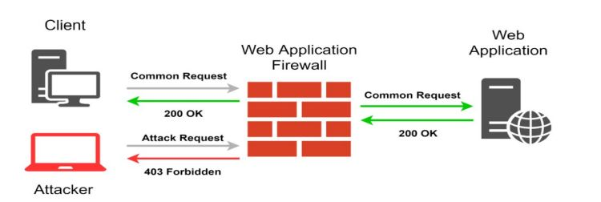

Figure WAF architecture

An Online Application Firewall (WAF) is a form of firewall devised to safeguard web applications. While a forward proxy server uses an intermediate to protect the client computer's identity, WAF deploys in front of web applications (in reverse proxy mode) & monitors bi-directional HTTP / HTTPS traffic to tempt & stop the harmful activity. WAFs are not the only protection solution; they should be used with other network perimeter security solutions such as next-generation firewalls (NGFW) & IPS.

In this (He, 2022), The classic border intrusion prevention paradigm is incapable of keeping up with the advancement of contemporary technologies. Zero trust is a novel network security approach built on the idea of never trusting and always verifying. It must be shown to access resources, whether the access topic is on the internal or external network. Because it can fulfill the new network security requirements, the zero trust paradigm has attracted much interest in research and practice. Nonetheless, the execution of zero trust is still in its infancy, and corporations, organizations, and individuals are not completely aware of the benefits and drawbacks of zero trust, which significantly impedes its use.

Authors assist in developing & executing future zero trust systems. This research describes the existing zero trust architecture & evaluates the essential technologies used in the zero trust architecture, such as verification, remote access, & trust evaluation. The primary solutions within each technology are contrasted & studied to portray the benefits & drawbacks, as well as current obstacles and future research directions show in below screen shots.

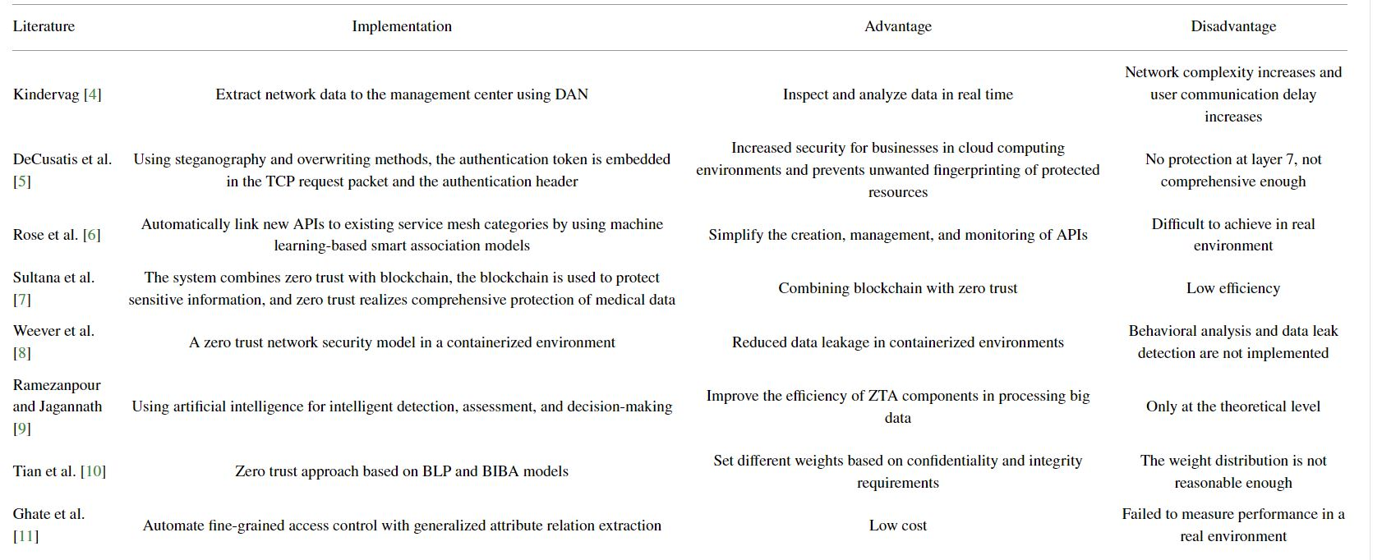

Figure 3 survey on previous research

They define ZT & clarify the history & expansion of this innovation. The ZTA's fundamental technologies are thoroughly examined: identity authenticity, network management, & trust evaluation. Authors review & define the advantages and disadvantages of examination study on verification, access management, or trust appraisal, as well as the critical complexities of each tool, & they suggest future efforts & outlooks. This paper's study has important implications for the future transfer of perimeter-based network security structures to ZTA.

In this (Sultana, 2020), Since the beginning of information exchange in e-health systems, data security has been a significant area of research and discussion. While data digitization has boosted efﬁciency, it has also rendered data more vulnerable to cyber threats. Medical logs, in particular, appear to be frequent targets of hackers. Several data breach occurrences throughout history have necessitated the development of security solutions to counter these threats. Although using numerous security methods such as gateways, VPN, cryptography, and so on, combining these measures is essential for optimal security in the medical picture and information sharing.

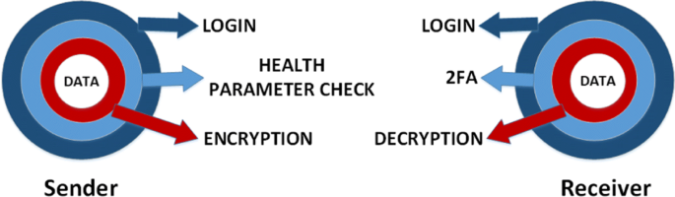

Figure Principle of ZTA

Blockchain technology has developed into an excellent tool for protecting sensitive data. To ensure robust security of medical data (pictures), security precautions must be completed at each stage, from the start, during, but after medical data transmission, as ensured by the strong authentication security paradigm. In this study, miscellaneous papers dealing with some of these two ideas were examined, & a decentralized & trustless architecture for saved medical data & picture transfer was presented by merging these two definitions.

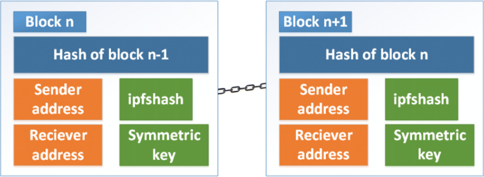

Figure Authors used block structure

According to the research findings, blockchain technology preserves data integrity by keeping an audit record of every commerce, while ZT regulations provide that biological data is encrypted & that only verified network participants participate with the network. As a result, the proposed method handles several data protection concerns.

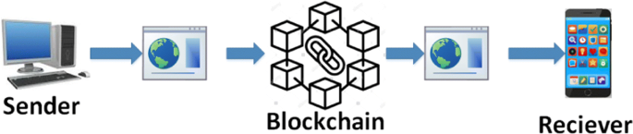

Figure proposed method

A solution has been suggested to handle medical/health data situations. Adopting this method implies increasing the security of medical or health data transfer. The system takes benefit of blockchain's immutability, the counted security of zero would, and the extensibility of off-chain data storage via Inter Planetary File Systems.

This research aimed to strengthen the security of medical information and photos (pre, through, then after transfer) by combining cryptocurrency & ZT concepts. ZT concepts were used to keep medical data secure during delivery and to improve user security. Blockchain technology was utilized to create a paper trail of health care data transfers for future review.

In this (Mandal, 2021), author used the SDN paradigm of cloud computing; they present a unique AC policy established on a ZT infrastructure by limiting incoming network traffic to prove MAC spoofing assaults. The multiplicative rise & additive reduction technique assists in detecting sophisticated MAC spoofing attacks before they penetrate SDN-based cloud systems. Founded on the suggested strategy, a customizable threshold is set to the received port digit. The threshold stamping's self-learning function aids in the correction of valid user traffic before organizing it for the attacker. Finally, the abstract & practical results outperform the existing approaches in terms of accuracy & positive predictive value.

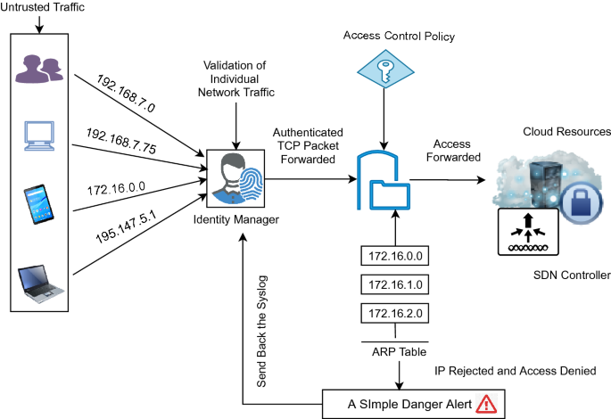

Figure 7 ZTA implementation in Covid 19

The proposed AC procedure uses the TAC layer to extract & analyze incoming TCP packets. Regardless, HTTP is utilized as the application layer protocol to establish a Network relationship with the cloud providers. The ZT network carefully verifies particular insecure IPs while establishing a connection with cloud services. The existing identity access management (IDM) cloud services, including AWS or Microsoft Web Directory, take charge of IP address authentication. An explicit trust is formed with the Ip from each guest, & IDM facilitates the creation of TCP connections for further access to cloud resources.

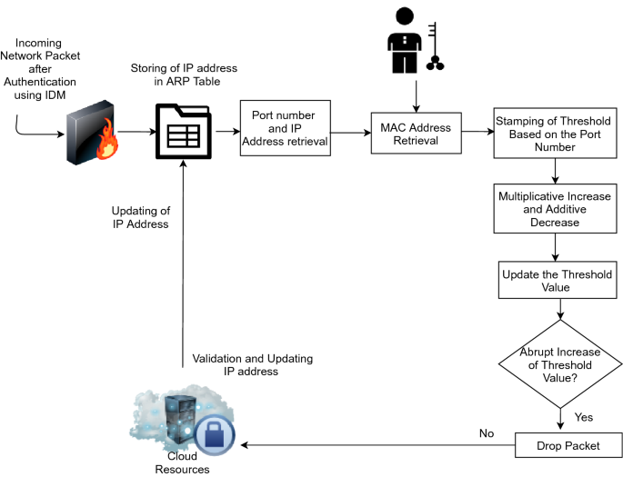

Figure Authors proposed ZTA

Proven hosts transmit ARP queries alongside their Ip. After receiving ARP answers, the connection weights corresponding to the IP addresses were saved in the ARP database. The ARP protocol also does Port number retrieval. Instead of inspecting the full TCP packet for the port version or source IP address, the explicit TCP heading has been checked, which decreases the overhead of inspecting every TCP offer. It will now maintain higher throughput with little network latency. Verified Ip should be routed through a virtualized gateway that implements our AC policy.

The author offers a unique AC policy based on a ZT network by developing a defensive mechanism against MAC spoofing in the cloud architecture's SDN framework. When the administrative structure's AC policies need to be changed, our approach provides more accuracy by collecting individual internet traffic from untrusted zones, comparing it to its source TCP/IP traffic, and matching MAC addresses. The occupation of the compound boost & additive decrease algorithms aids in the detection of sophisticated MAC spoofing attacks before they penetrate the Infrastructure cloud approach.

## Summary:

This chapter examines the work done by other researchers. The next chapter echoes the research methodology.

# CHAPTER 3: Research Methodology

.

In this I describe the methodology of the zero trust architecture. First i introduce different ZTA models. Section 3.1 I highlight the case study of ZTA in the organization. Section 3.2 Details analysis high level methodology. Section 3.3 describe the cloud base ZTA methods

The ZTA  revolutionized security & privacy. It proved that remote access to the database record would have the same amount of safety as the capacity to gather info from a fixed computer on the institution's premises. It can be shown that the Zero Trust Architecture method allows employees to have access regardless of geography below figure. The computer's position does not affect the security settings. It is very useful in the present epidemic situation. The percent of workers stay home or cannot travel to their offices.

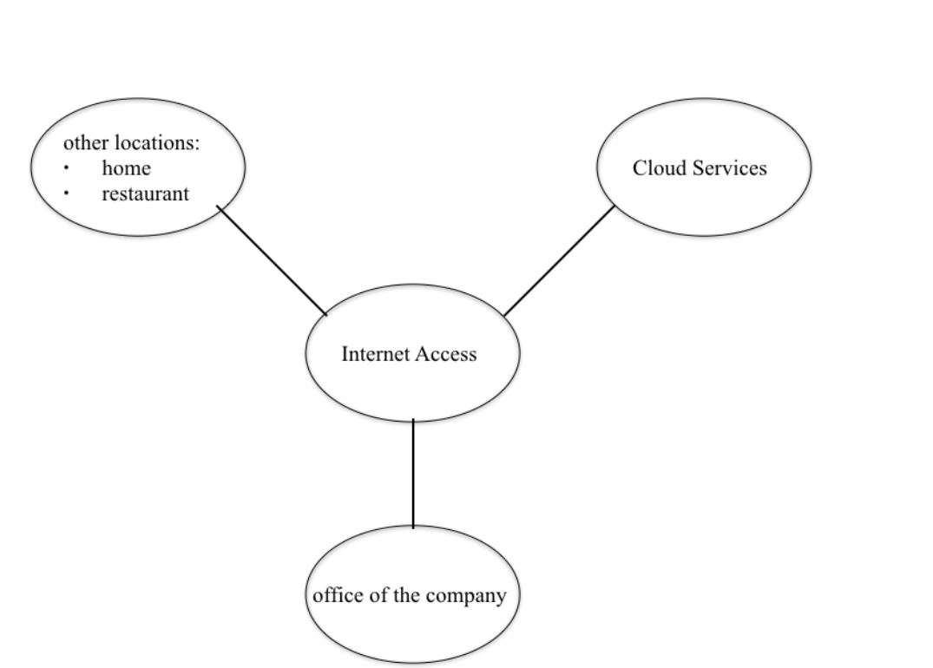

Figure with zero trust model various access the services

Another key improvement made possible by ZTA is the automated process of device & client verification. This technology reduces the risk of error and operates considerably faster than a human-made verification technique. Based on the computer data, the program "decides" whether this individual is trustworthy. Furthermore, access to select elements of the information can be granted based on the worker's location & area of competence. Furthermore, is the material safe, as is the interaction among the company's personnel? This capability is essential in the case of remote work. It contributes to more conversation freedom and substitute’s communicators & media platforms. It is also vital to note that cloud services allow for secure doc & file exchange across co-workers.

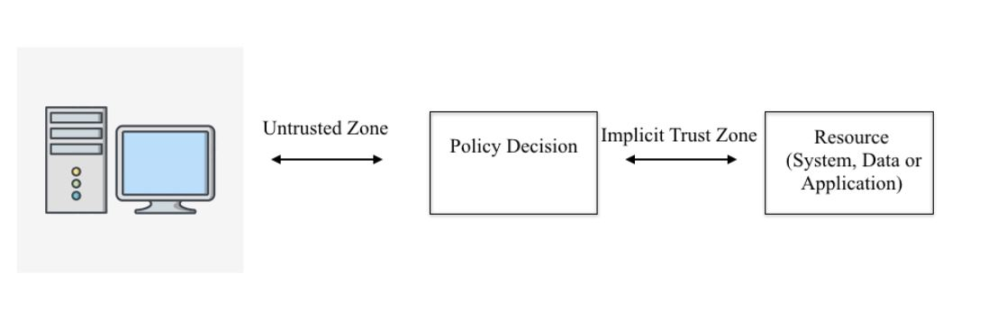

Figure 10 Analyze flow diagram in ZTA.

Authentication mechanism on a regular schedule, independent of the device's IP address or the consumer experience parameters. The methods utilized by ZTA must also be studied because they are novel in cybersecurity. The system employs several metrics to ensure the verification method is safe for all parties. It is useful if the device is stolen and an effort is made to access the computer. Because the application is founded on "zero trust," outside users would not be able to see all the information.

ZTA  is an adaptable architecture that can be tailored to the organization's demands. It is vital to note that perhaps the system is automated, making its adoption easier for businesses without an IT department (Li, 2022). The organization's executives can employ an expert to implement the essential programs if the ZTA  system works properly, so there is no need to compensate the programmer. However, because each organization operates differently, the policy decision-making process should be arranged differently. It is feasible, for instance, to grant people from the total workplace access without requiring a verification procedure.

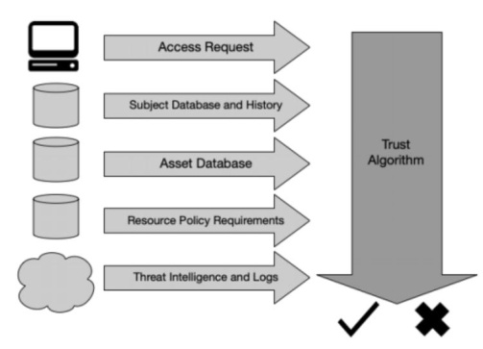

Figure Mechanism in action in ZTA

Another critical element is the security of the program's database; it operates on dynamic policy principles. It implies that there is no one folder in which all of the information transferred and viewed is preserved. It is advantageous to the firm since it is impossible to access all data in a single effort. Even if the cyber-attack is carried out, just a portion of the information may be stolen. Furthermore, the system captures and communicates traffic and asset status data with the headquarters. It enables the company's computer professionals to resolve the issue promptly.

## 3.1 Case study of different cases:

Contributions from trade associations expressing interest in participating in this initiative will influence the composition and quantity of cases displayed. These situations capture the concept of granting subjects access to company information sources on-premises or on the cloud Requests for access may arise from within the. In the event of workers, the company network or the public internet is used. The assumption is that. A business is executing a ZTA within a current traditional corporate setting.

### Case 1: Employee Internet Resource Availability

A person endeavours to connect to the general internet to do some tasks. This case depicts a specific user understanding in which a worker seeks to utilize an organization device to connect to an organization's web-based service on the internet. Although the organization does not control or operate the web-based service, the corresponding permit request for that commodity will be enforced dynamically and in real-time by a ZTA delivered in this project. Irrespective, the technology will control the employee's access. The employee can use an enterprise-managed device to access the internet while linked to the company intranet, a branch office, or the public internet.

Suppose a worker is permitted by business policy to use organization devices to connect non-enterprise-managed information and services on the public internet. In that case, the ZTA solution allows them to do so for the company to ascertain the scope of this access limitation in the preceding section might include:

* Social media permit is not permitted.
* Internet search engine access is authorized, as the related access request for this resource must not be made available over the corporate network when an employee works at a branch office or while teleworking (for example, in a coffee shop or the airport).
* Crucial services on the shared internet (e.g., GitHub) can be accessed directly by an employee.

### Case study 2: Inter-server Communication Within the Organization

The connection between various servers inside the Organization clients frequently communicates. A web server, for example, connects with an application server. The application server addresses a database to return data to the web server. The ZTA solution in this project would enforce the network connections across authorized servers that engage with one another constantly and in near real-time. This scenario will provide examples of inter-server interactions inside the organization, including servers on-premise, in the cloud, or between servers on-premise and in the cloud.

### Case study 3: Create a trust score/level of confidence using corporate resources.

Organizations have tracking systems, SIEM systems, and other resources that can provide data to a policy engine to support security analytics and create a more granular trust score/confidence level for access to corporate resources, enabling strict access based on the confidence level. In this case, a ZTA will link these monitoring & SIEM systems with the policy engine to provide more exact trust scores/confidence levels in real-time.

### Case Study 4: Access to Enterprise Resources for Employees

An employee wants simple & secure access to enterprise resources from any work location. This case will show a specific user experience in which an employee seeks to access corporate services, including the computer network, an attendance system, and perhaps other human resources systems through an organization device or a personally owned device. The ZTA technology, in this case, will instantly & in near real-time enforce the linked access request. The employee will be able to complete the following tasks:

• Use the business intranet to access on-premises corporate resources.

• Access organizational information in the cloud directly linked to the business intranet.

• Access corporate resources on-premises while linked from a branch office.

• Use a branch office connection to access corporate resources in the cloud.

• Use the public internet to access on-premise business resources while teleporting.

• Use the public internet to access organizational cloud services while working remotely.

## 3.2 High level Methodology:

A high-level Methodology is the fictitious architecture of the logical & functional segments that may include a typical IT business's ZTA will shown below (Kerman, 2020).

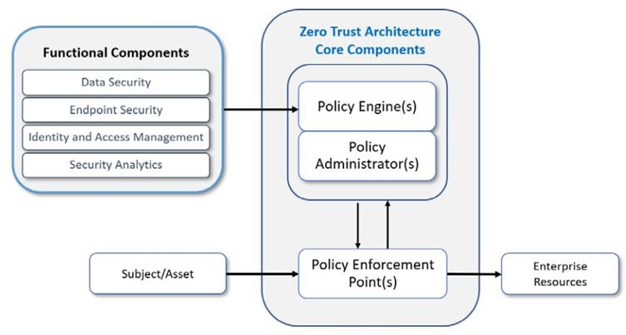

Figure 12 High level ZTA methodology

### List of Features

The following specialized features are required for the ZTA.

#### Core Components:

* The policy engine chooses whether to allow, deny, or revoke access to a resource for a certain subject. The policy engine computes trust scores/belief levels & conclusive access preferences.
* The policy administrator is in charge of initiating & concluding the transaction between a subject and a resource. It creates any session-specific authentication & any authentication token or credential that a client uses to access an enterprise resource. It is inextricably linked to the policy engine and relies on its decision to accept or prohibit a session.
* The policy enforcement point is in charge of connecting a subject to an enterprise resource & monitoring & eventually terminating the connection.

#### Functional components:

* Information security involves a series of all the data access regulations and controls that a company establishes to safeguard its information and the tools to protect data at rest and in transit.
* The vulnerability management component includes the strategy, technology, and governance for protecting endpoints (servers, PCs, IoT, and smart mobiles) from threats & assaults & the industry from managed and unmanaged risk tools.
* The method, technology, & authority for establishing, storing, and industry & the effect user (i.e., subject) accounts & individual records, as well as their access to corporate resources, are all part of the authentication and authorization component.
* It collects security & analysis tools on enterprise assets' present state and continuously monitors those assets to respond to threats or criminal behavior. This data might be sent into the part of its operations to aid in making dynamic access choices. The advanced analytic part includes an IT company's current cyber threat channels & traffic/activity tracking.

#### Features of Network Infrastructure & Devices:

* Assets include devices/endpoints connected to the organization, such as tabs, IoT, and mobiles and laptops
* Enterprise resources include data and computing resources, as well as applications and services hosted and managed on-premises, in the cloud, at the edge, or a mix of these.
* Network infrastructure features include any network resources that a medium or large organization could need in its environment. Both the ZTA core & network are expected to connect or integrate functional components and devices.

## 3.3 Cloud based implementation of Zero trust model

In this research, i use cloudflare for implementing zero trust models. Cloud flare ZTreplaces old security perimeters with our global edge, allowing teams all across the world to connect quicker and more securely.

### All of your applications will have ZT cloudflare access.

* Users on our international perimeter network must be authenticated.
* Easily integrate third-party users. Log every event and request A Secure Web Gateway to secure users and devices.

### Enforce your organization's AUP:

* Block dangerous websites using custom blocklists and built-in threat intelligence.
* Enhance visibility & protection in SaaS apps
* A speedy and reliable isolated browsing choice.

All browser code should be performed on the cloud.

* Decrease the severity of attacks
* End-user experience that is seamless & lightning-quick

## What is identity on Cloudflare ZT?

To implement ZT & Web Application Interface rules, Cloudflare Zero Trust connects with your firm's authenticator. You can merge numerous identity providers simultaneously if you collaborate with partnerships, vendors, or other organizations.

Cloudflare ZT may send an OTP to privileged email addresses rather than specifying an authentication protocol. There is no need for installation; add a user's email id to a Use rule and the subgroup that permits your organization to access the program.

You may simultaneously configure an OTP $ identity provider to allow users to utilize their preferred authentication method.

Cloudflare Zero Trust may also connect with endpoint defense vendors to validate device pose recommendations. This allows you to set protection policies that allow or deny app links based on extra signals from endpoint security providers.

* Login page
* OTP
* User management
* Single sign on integration
* Device posture

### Role and permission on cloudflare:

When i create a Cloudflare Zero Trust account, I will be allocated the Super Administrator position. I may use this position to invite people to my ZT account & assign them various duties based on the privileges i want to deliver.

## Summary:

This chapter research on methodology and some case studies. The next chapter will be implementation.

# CHAPTER 4: Implementation

This chapter goes through the implementation of ZTA in-depth. All studies are recorded via screenshots.

## 4.1 Implementation of Cloud flare ZTA

This section displays the implementation of the Cloud flare ZTA solution.

### Installation & configuration of Dashboard

* Choose to have a team name on the on boarding page.

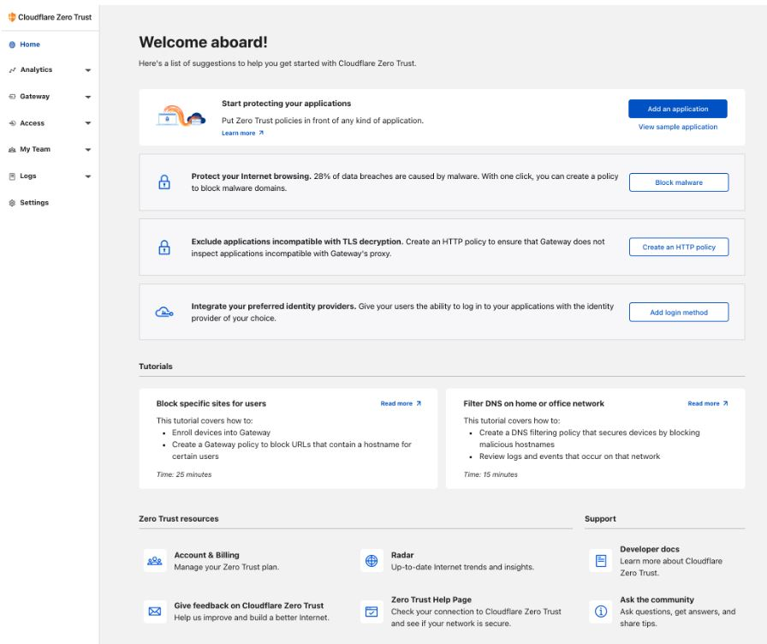

Figure boarding page

* Select a subscription plan & submit your payment information to complete your onboarding. If we choose the Zero Trust Free plan, please remember that this step is still required, but we will not be charged.

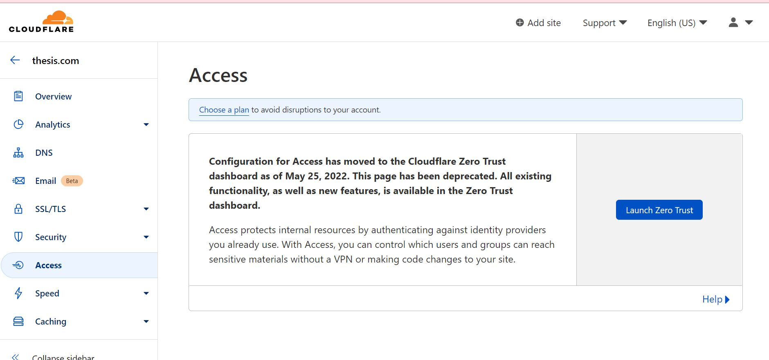

Figure Dashboard screen after creating account

Now, i launch the zero trust

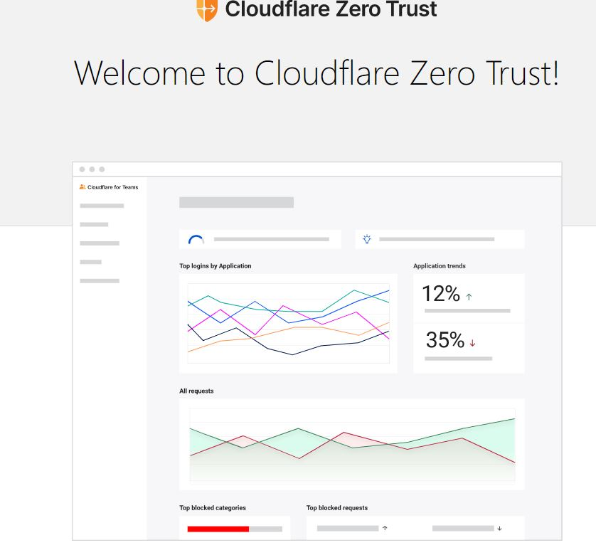

Figure welcome to ZT screen

When it launch a dashboard is appear on the screen.

Now, we give the name of my team.

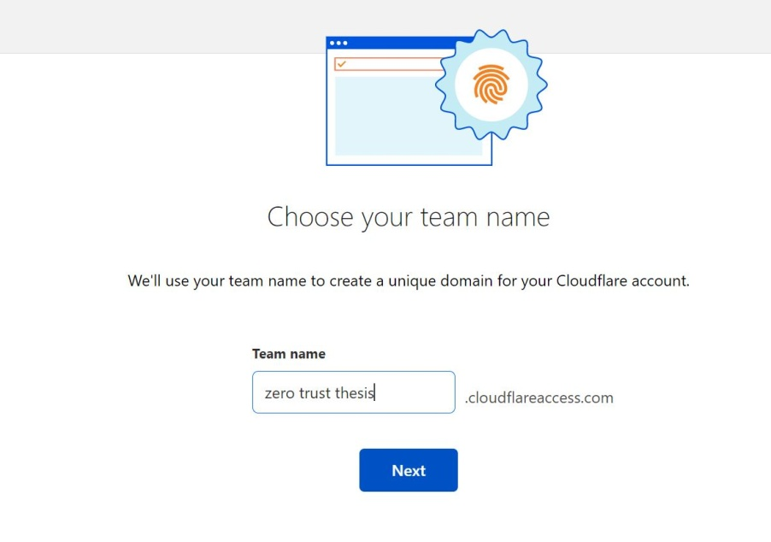

Figure input team name

Welcome screen is appear

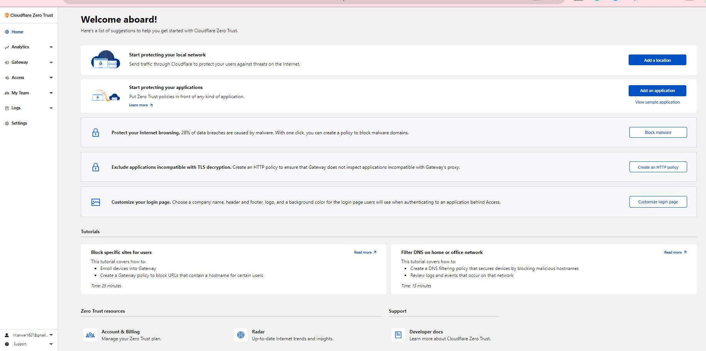

Figure welcome dashboard

Now, i add the location of DNs and give ip address

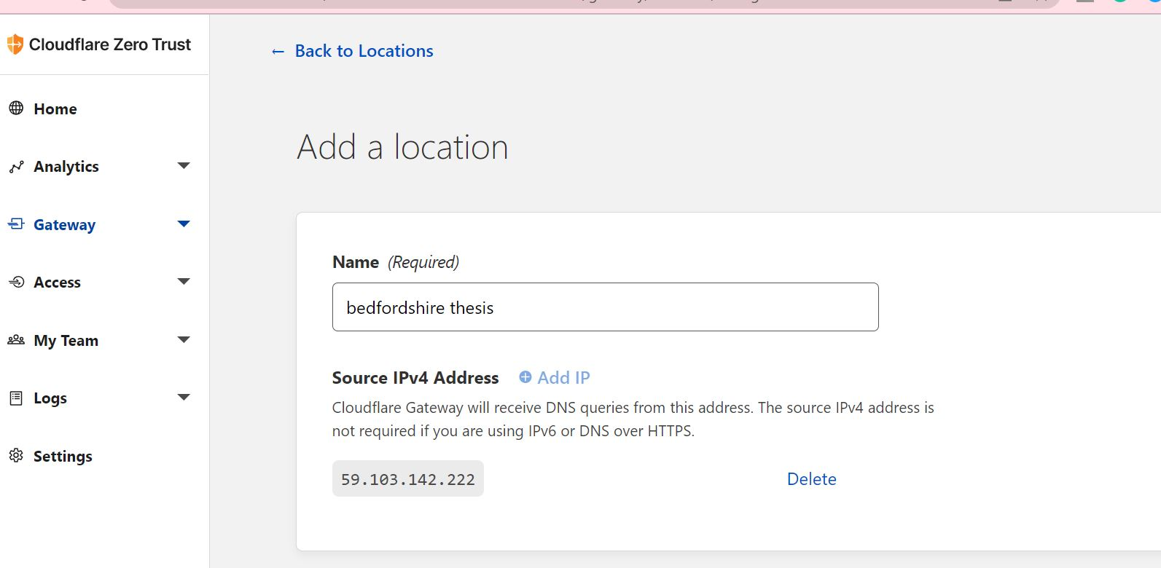

Figure add the location of DNs and give ip address

### Add application:

There are multiple application on the dashboard, i selected Private network .

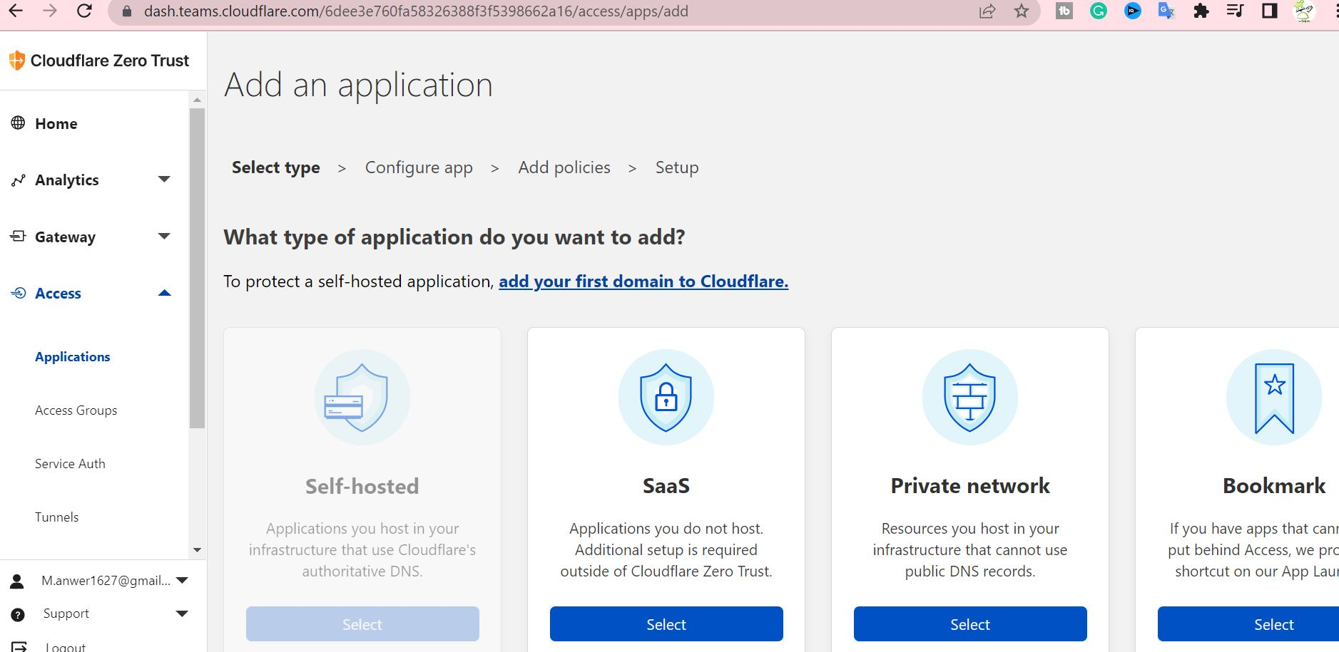

Figure Dashboard for adding application

Now, we configure application details and give name

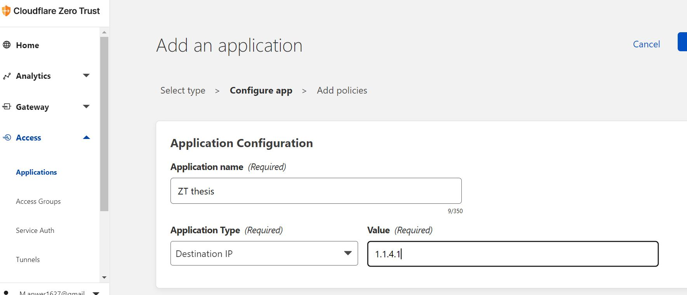

Figure Application name

We select default, because we just created a demo of ZTA in this research We don’t have paid subscription.

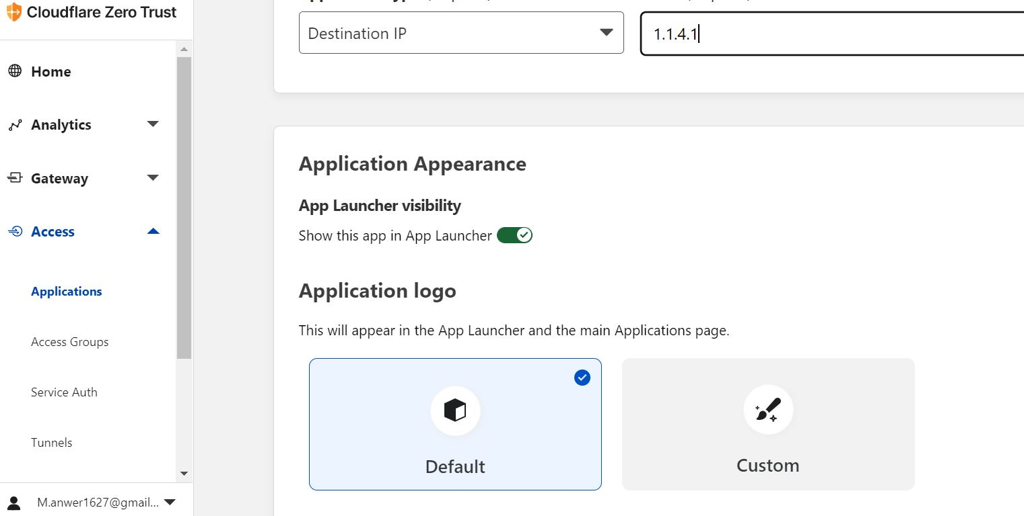

Figure Application logo

## Policy creations

In this we have to create a policy who can access this. Policies we create here can also be viewed and managed under gateway and select Network Policies

Press save now create policies

#### Policy 1:

In policy 1 we allow rule for the group which can access is app.

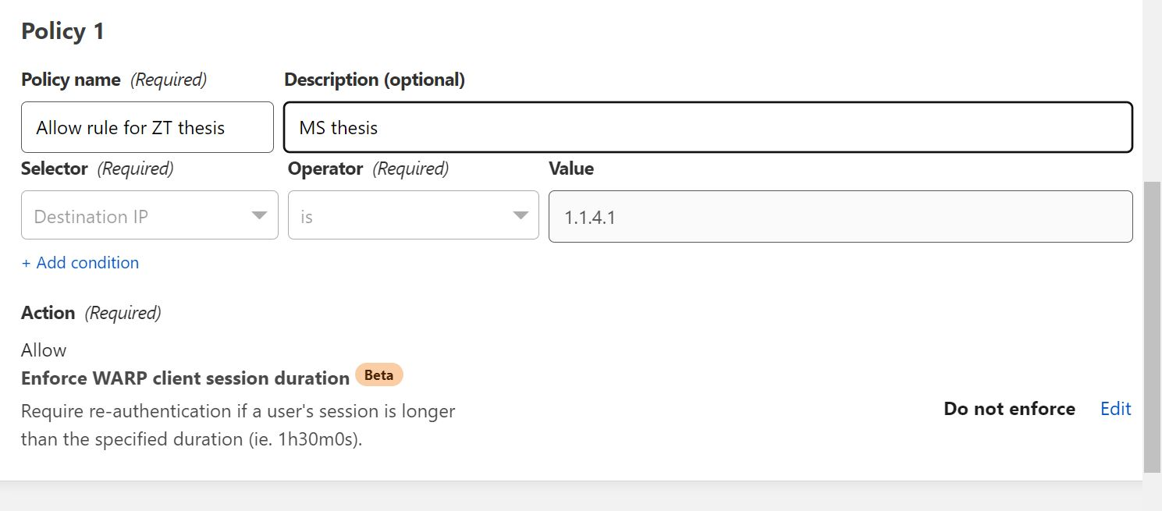

Figure Policy 1

#### Policy 2:

In policy 2 we block rule for those group members who can’t access this.

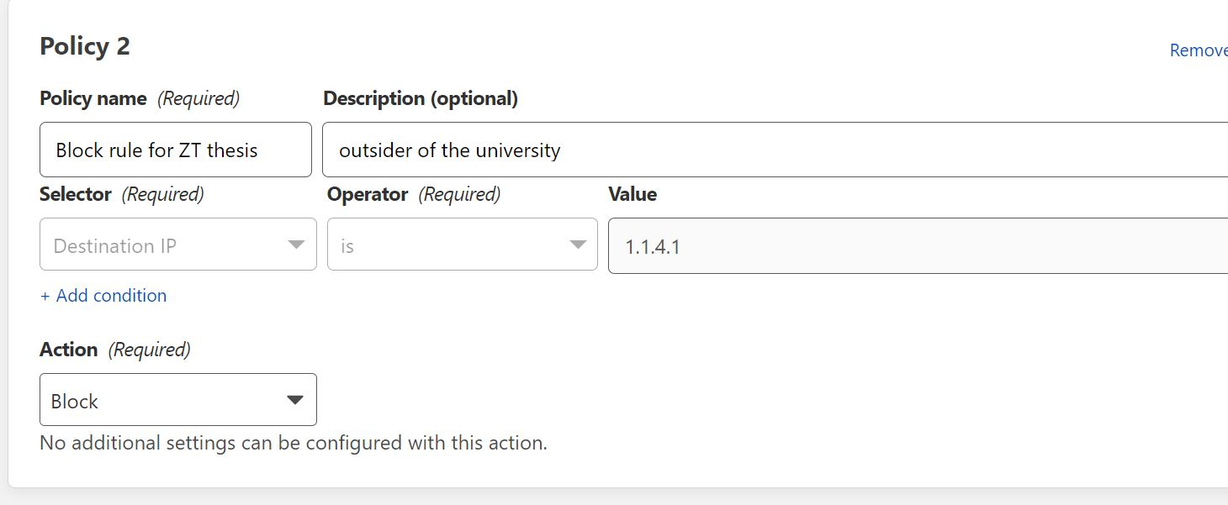

Figure Policy 2

The ZTA is implement on our account.

# CHAPTER 5: Testing / Results

In this chapter, we will investigate and test the results performed and check ZTA which we implemented in previous chapter.

Now environment is set up, we have in-depth visibility into our network activity.

## 5.1 Check Cloud flare ZT devices:

First select My Team then goto Devices to get a list of our enrolled devices, the last time they were seen, & the WARP client version they are using. There is filter option also, i can filter email, products, limits and date and time (Anon., n.d.).

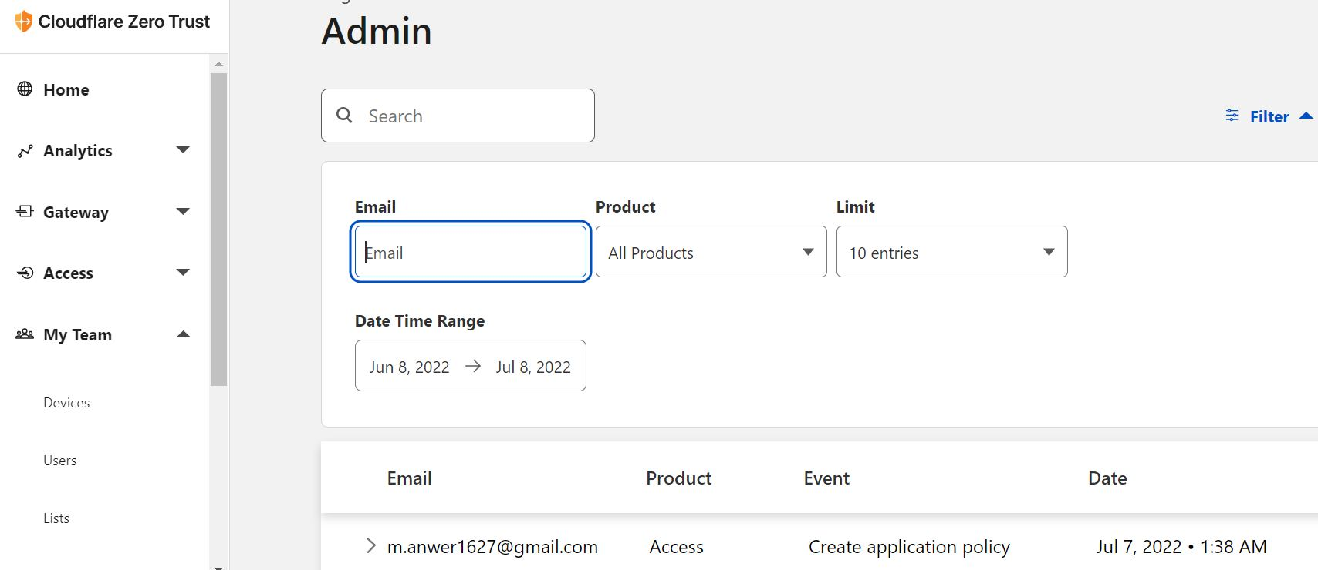

Figure View Devices in Cloudflare ZT

## 5.2 Check user in ZT:

Click to My Team then select Users to see who is presently an active user in my ZTA, revoke users, & view details such as the person's last login, location, and devices. I can also filter and export the data in CSV format for further analytic.

Currently, i have none user because i show only how i implement ZTA on cloudflare.

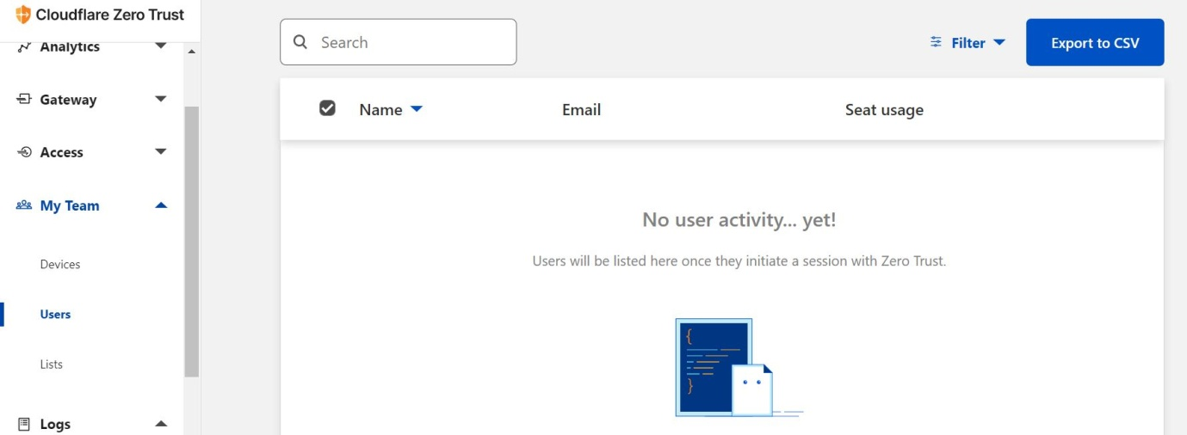

Figure View users

## 5.3 Data Analytics

Click to the Analytics section to see whether the SaaS apps users are using & a breakdown of the most popular Allowed and Blocked requests.

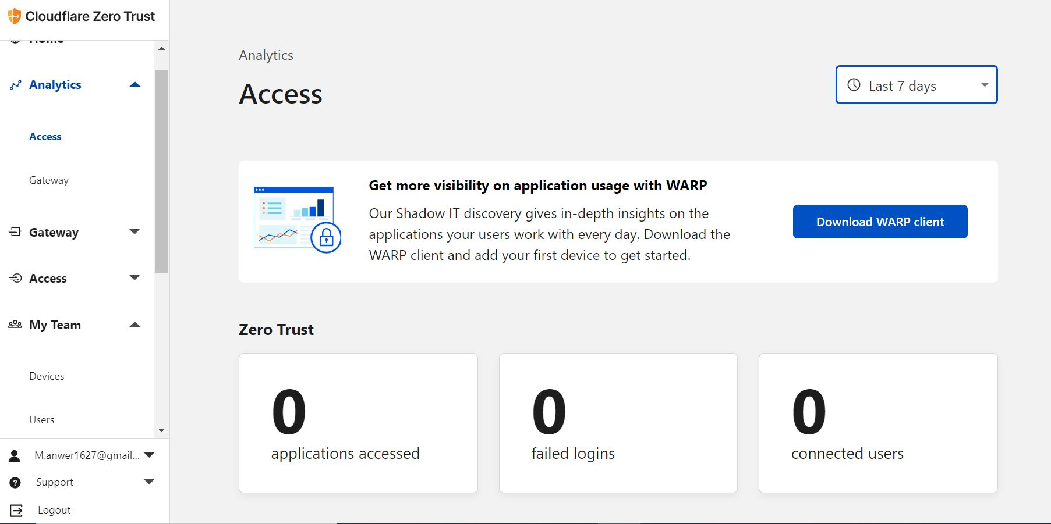

Figure Data Analytics Dashboard

5.4 Analysis Logs.

Proceed to the Logs area for a summary of network occurrences. Examine which permissions were made, which queries were screened by Gateway, and what action was taken on each of them.

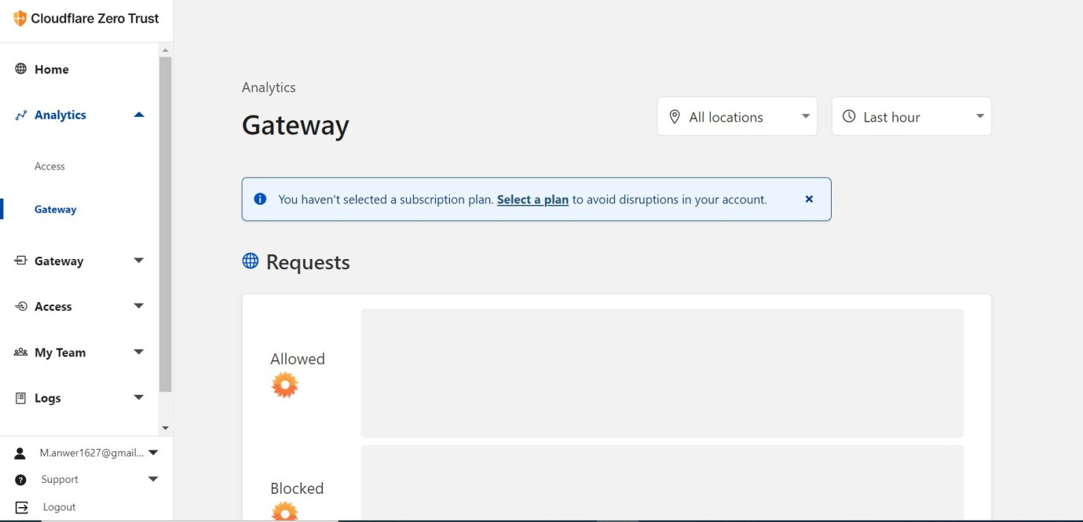

Figure Log analysis

We have successfully implement the ZTA on cloudflare.

## Summary:

This chapter explained testing and results performed after the different experiments on the ZT on cloud flare. Next chapter would reflect the conclusions derived from the research.

# CHAPTER 6: Conclusions

ZTA is a novel technique for collecting & managing company data. Its key advantage is accessing it from any region and on every device. It limits the quantity of information & needs the standard procedure on a regular schedule, lowering the danger of computer security. The possibility of granting partial access to data is advantageous for data security and arranging the hierarchical system inside the company.

I cover the idea and use of ZTA in this research. Some obstacles with ZTA are mentioned & discussed, such as a lack of standardization & vendor lock-in issues. Finally, a summary of the methods and considerations for cloud-based Zero trust architecture on cloud flare was implemented.

# References

Adahman, Z., 2022. Zero-Trust Architecture and Its Cost-Effectiveness on Network Security.

Albuali, A. T. M. a. D. C., 2020. ZTIMM: A zero-trust-based identity management model for volunteer cloud computing. *In International Conference on Cloud Computing, pp. 287-294. Springer, Cham,.*

Anon., n.d. [Online]   
Available at: https://dash.teams.cloudflare.com/6dee3e760fa58326388f3f5398662a16/home/quick-start

Buck, C. C. O. A. S. F. V. a. T. E., 2021. Never trust, always verify: A multivocal literature review on current knowledge and research gaps of zero-trust.. *Computers & Security 110.*

Campbell, M., 2020. Beyond zero trust: Trust is a vulnerability.". *Computer 53.10 .*

Dimitrakos, T. T. D. A. K. A. L. M. F. M. A. R. A. R. a. A. S., 2020. Trust aware continuous authorization for zero trust in consumer internet of things.. *In 2020 IEEE 19th International Conference on Trust, Security and Privacy in Computing and Communications (TrustCom), pp. 1801-1812. IEEE, 2020..*

do Amaral, T. M. S. a. J. J. C. G., 2021. "Integrating Zero Trust in the cyber supply chain security.. *In 2021 Workshop on Communication Networks and Power Systems (WCNPS), pp. 1-6. IEEE, .*

Flanigan, J., 2018. Zero Trust Network Model. *Tufts University: Medford, MA, USA.*

Garbis, J. a. J. W. C., 2021. Zero Trust Security: An Enterprise Guide.. *Berkeley, CA: Apress,.*

Gasti, P. G. T. E. U. a. L. Z., 2013. DoS and DDoS in named data networking.. *In 2013 22nd International Conference on Computer Communication and Networks (ICCCN), pp. 1-7. IEEE.*

Gilman, E. a. D. B., 2017. Zero trust networks.. *O'Reilly Media, Incorporated,.*

Greenwood, D., 2021. Applying the principles of zero-trust architecture to protect sensitive and critical data.. *Network Security 2021, no. 6.*

He, Y. D. H. L. C. Y. N. a. X. M., 2022. A Survey on Zero Trust Architecture: Challenges and Future Trends.. *Wireless Communications and Mobile Computing 2022.*

Kerman, A., 2020. Implementing a zero trust artitecture. *NIST.*

Kerman, A. O. B. S. R. a. A. T., 2020. Implementing a zero trust architecture.. *National Institute of Standards and Technology (NIST) .*

Li, D. E. Z. M. L. a. C. S., 2022. Zero trust in edge computing environment: a blockchain based practical scheme.. *Mathematical Biosciences and Engineering 19, no. 4 (2022): 4196-4216..*

Mandal, S. D. A. K. a. S. J., 2021. Cloud-based zero trust access control policy: an approach to support work-from-home driven by COVID-19 pandemic.. *New Generation Computing 39, no. 3.*

Mehraj, S. a. M. T. B., 2020. Establishing a zero trust strategy in cloud computing environment.. *In 2020 International Conference on Computer Communication and Informatics (ICCCI),.*

Ramezanpour, K. a. J. J., 2021. Intelligent zero trust architecture for 5g/6g tactical networks: Principles, challenges, and the role of machine learning.. *arXiv preprint arXiv:2105.01478 .*

Samaniego, M. a. R. D., 2018. "Zero-trust hierarchical management in IoT. *In 2018 IEEE international congress on Internet of Things (ICIOT), pp. 88-95..*

Simpson, W. R. a. K. E. F., 2020. Resolving Network Defense Conflicts with Zero Trust Architectures and Other End-to-End Paradigms.. *International Journal of Network Security & Its Applications (IJNSA) .*

Stafford, V. A., 2020. Zero trust architecture. *. NIST Special Publication, 800, 207..*

Sultana, M. A. H. F. L. K. A. T. a. M. N. I., 2020. Towards developing a secure medical image sharing system based on zero trust principles and blockchain technology.. *BMC Medical Informatics and Decision Making 20, no. 1.*

Wu, Y. G. W. H. Y. a. J. Z. W., 2021. Real identity based access control technology under zero trust architecture. *In 2021 International Conference on Wireless Communications and Smart Grid (ICWCSG), pp. 18-22. IEEE.*

Yan, X. a. H. W., 2020. Survey on zero-trust network security.. *In International Conference on Artificial Intelligence and Security, pp. 50-60.*

Yao, Q. Q. W. X. Z. a. J. F., 2020. Dynamic access control and authorization system based on zero-trust architecture.. *" In 2020 International Conference on Control, Robotics and Intelligent System, pp. 123-127..*

# Appendices

## Appendix 1: Cloud flare

|  |
| --- |
| { |
|  | "Aside with header": { |
|  | "prefix": ["asideheader"], |
|  | "body": [ |
|  | "{{<Aside type=\"${1|note,warning|}\" header=\"${2:header}\">}}", |
|  | "$0$TM_SELECTED_TEXT", |
|  | "{{</Aside>}}" |
|  | ], |
|  | "description": "Aside shortcode with header text", |
|  | "scope": "markdown" |
|  | }, |
|  | "Aside without header": { |
|  | "prefix": ["asidenoheader"], |
|  | "body": [ |
|  | "{{<Aside type=\"${1|note,warning|}\">}}", |
|  | "$0$TM_SELECTED_TEXT", |
|  | "{{</Aside>}}" |
|  | ], |
|  | "description": "Aside shortcode without a header", |
|  | "scope": "markdown" |
|  | }, |
|  | "Surround with content-column": { |
|  | "prefix": ["ccol"], |
|  | "body": [ |
|  | "{{<content-column>}}", |
|  | "", |
|  | "$0$TM_SELECTED_TEXT", |
|  | "", |
|  | "{{</content-column>}}" |
|  | ], |
|  | "description": "Surround selection with content-column shortcodes", |
|  | "scope": "markdown" |
|  | }, |
|  | "Surround with table-wrap": { |
|  | "prefix": ["tblwrap"], |
|  | "body": [ |
|  | "{{<table-wrap>}}", |
|  | "", |
|  | "$0$TM_SELECTED_TEXT", |
|  | "", |
|  | "{{</table-wrap>}}" |
|  | ], |
|  | "description": "Surround selection with table-wrap shortcodes", |
|  | "scope": "markdown" |
|  | }, |
|  | "Directory listing": { |
|  | "prefix": ["directory"], |
|  | "body": [ |
|  | "{{<directory-listing>}}" |
|  | ], |
|  | "description": "Add directory-listing shortcode", |
|  | "scope": "markdown" |
|  | }, |
|  | "Markdown header: full file": { |
|  | "prefix": ["headerfullfile"], |
|  | "body": [ |
|  | "---", |
|  | "title: ${1:title}", |
|  | "pcx-content-type: ${2|overview,concept,how-to,configuration,reference,navigation,best-practices,faq,tutorial,glossary|}", |
|  | "weight: TODO", |
|  | "---", |
|  | "", |
|  | "# ${1:title}", |
|  | "", |
|  | "$0" |
|  |  |
|  | ], |
|  | "description": "Header for a complete Markdown file", |
|  | "scope": "markdown" |
|  | }, |
|  | "Markdown header: partial file": { |
|  | "prefix": ["headerpartialfile"], |
|  | "body": [ |
|  | "---", |
|  | "_build:", |
|  | " publishResources: false", |
|  | " render: never", |
|  | " list: never", |
|  | "---", |
|  | "", |
|  | "$0" |
|  | ], |
|  | "description": "Header for a partial Markdown file", |
|  | "scope": "markdown" |
|  | }, |
|  | "Markdown header: add meta title": { |
|  | "prefix": ["metatitle"], |
|  | "body": [ |
|  | "meta:", |
|  | " title: $0" |
|  | ], |
|  | "description": "Meta title in Markdown header", |
|  | "scope": "yaml" |
|  | }, |
|  | "Render/include partial": { |
|  | "prefix": ["partialinclude", "renderpartial"], |
|  | "body": [ |
|  | "{{<render file=\"$0\">}}" |
|  | ], |
|  | "description": "Includes content from a partial in the current document", |
|  | "scope": "markdown" |
|  | }, |
|  | } |

## Appendix 2: cloudflare contents.ts

|  |
| --- |
| type ListItem = HTMLLIElement & { |
|  | h: string; |
|  | }; |
|  |  |
|  | export function toc() { |
|  | let target = document.querySelector('ul.DocsTableOfContents'); |
|  | let article = target && document.querySelector('article.DocsMarkdown'); |
|  |  |
|  | if (article) { |
|  | let headers = article.querySelectorAll('h2,h3,h4'); |
|  | let i = 0, |
|  | tmp: Element, |
|  | last: ListItem, |
|  | container = target; |
|  | if (!headers.length) return; // exit & leave hidden |
|  |  |
|  | for (; i < headers.length; i++) { |
|  | tmp = headers[i]; |
|  |  |
|  | if (tmp.nodeName === 'H2') { |
|  | container = target; |
|  | } else if (last && tmp.nodeName > last.h) { |
|  | // eg; "H4" > "H2" ==> true |
|  | container = last.appendChild(document.createElement('ul')); |
|  | } else if (last && tmp.nodeName < last.h) { |
|  | container = container.parentElement || target; |
|  | } |
|  |  |
|  | last = document.createElement('li') as ListItem; |
|  | let text = tmp.lastElementChild.textContent.trim(); |
|  | last.innerHTML = `<a class="DocsTableOfContents-link" href="#${tmp.id}">${text}</a>`; |
|  | container.appendChild(last); |
|  | last.h = tmp.nodeName; |
|  | } |
|  |  |
|  | target.removeAttribute('hidden'); |
|  | } |
|  | } |